Internet of Things

Project Title - Smart Farming

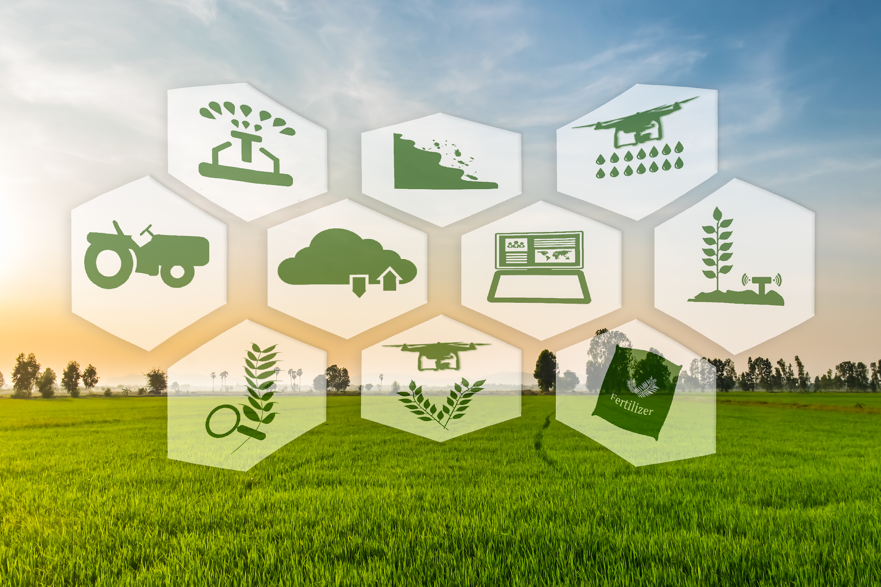

**Meghna Lohani 16BCE1395**

**Aman Sharma 16BCE1224**

**Kothuri Sai Phanindra 16BCE1075**

Abstract

Our goal will be to basically collect information from a local unit and send it to the internet. A user anywhere on the planet looking at this information will make decisions by sending remote commands to the actuators, which will also be in this local unit. Actuators can also turn on/off automatically based on the sensor data.

The data to be collected by sensors will be:

* Air Temperature and relative humidity
* Soil Temperature and humidity
* Luminosity

The project will has two actuators:

* Electrical Pump
* Electrical Lamp

The status of those actuators ("ON/OFF"), should be also sent to the cloud.

So, the idea will be to capture those data from the sensors, for example, a plantation and send them to cloud. Based on those data, the actuator will take the decision based on those statements:

* Turn ON the Pump if the soil humidity is too low (Less than 60%)
* Turn ON the Lamp if the soil temperature is too low. (Less than 15 oC)

Protocol Stack

|  |  |
| --- | --- |
| **Layer** | **Protocol used** |
| Application Layer | HTTPS |
| Transport Layer | TCP |
| Internet Layer | IPv4 |
| Data Link | Wifi |
| Physical Layer | UART (Universal Asynchronous Transmitter and Receiver) |

Individual Contribution

**Meghna Lohani 16BCE1395**

* Connected the sensors locally
* Code for capturing data from the sensors
* Sending the captured data from the microcontroller to the serial monitor and to the cloud.
* Installing the actuators.

**Aman Sharma 16BCE1224**

* Configured the ESP8266
* Configured the ThingSpeak Channel to receive sensor data from the cloud.
* Analytics using ThingSpeak to notify the user with email and sms if there is any drastic change in the sensor readings.
* Configuring actuators with ThingSpeak

**Kothuri Sai Phanindra 16BCE1075**

* Smart farm app for monitoring status and controlling the actuators.
* Configuring the app to take decisions based on cloud sensor values.
* Controlling the actuators by sending commands to the cloud.
* Fetching data from the cloud into the application.

Communication Channel

ThingSpeak.com

Challenges Faced

* Configuring ESP
* Getting the data from the cloud and taking actions based on it on a different network.

Screenshots

**Circuit**

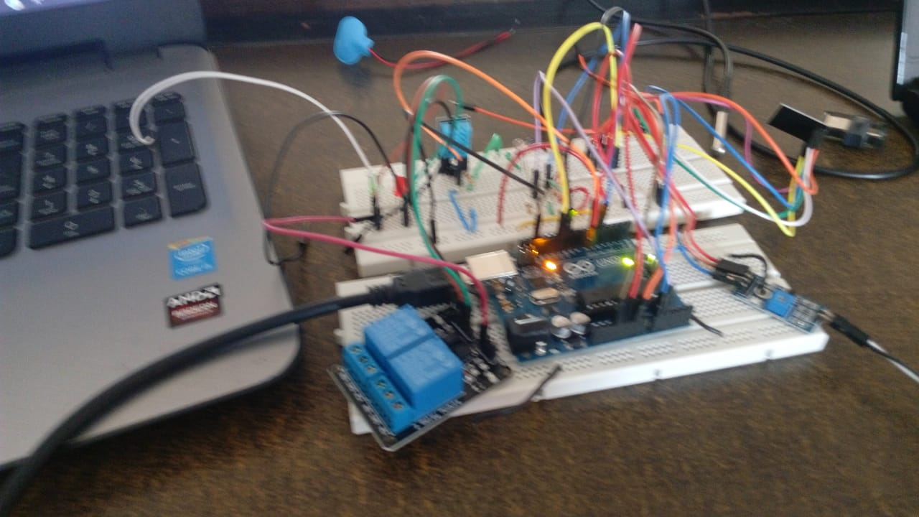

**ThingSpeak Channel with sensor data**

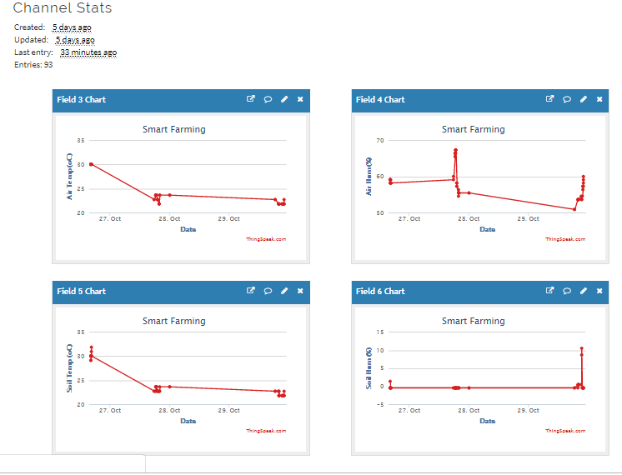

**Email and sms notification to the user.**

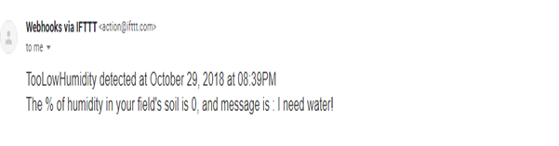

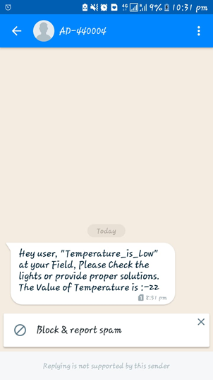

**Application**

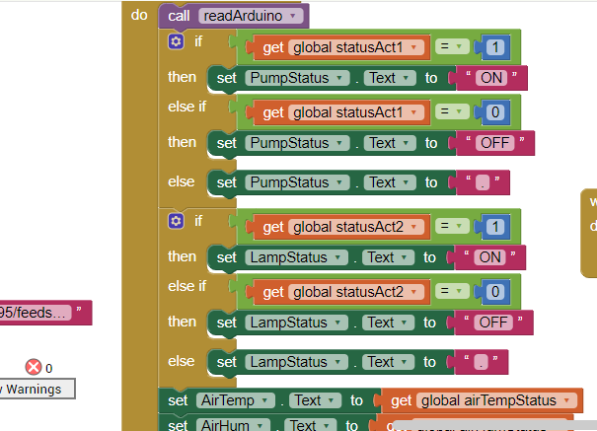

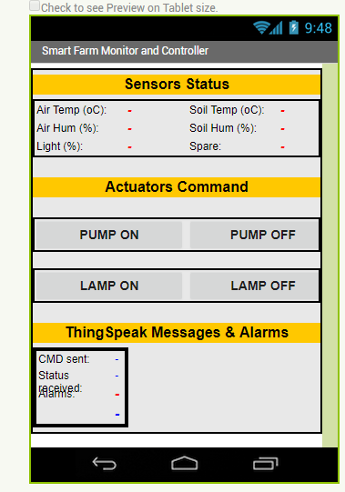

Industrial application of the project

This project can be used by farmers to automatically switch on/off the water pump when required. It will save wastage of water and prevent crops from excessive as well as water shortage.

Farmers can also control the water pump and light from their apps in conditions when they can’t visit the farm.

The project will result in better farming methods , prevent wastage of water and will prevent crops from dehydration.